VPC configuration

VPN stands for Virtual private network, it is mainly used to establish secure connection between your devices and a remote server over the public network.
That means it creates a secure, encrypted connection (called tunnel) over a public network (internet) to a private network. Think of it like building a private, protected road through a public highway.
You’re Device
Internet
Private Network
Remote Server

Fig: Establishing of secure connection (tunnel) using VPC over Internet (public network).

It masks your IP address, encrypts your data, and allows secure access to private networks even when you’re connected through a public network.

Why Do We Use a VPN?
- Secure remote access to private networks (e.g., corporate or cloud resources).
- Encrypt data traffic to protect from hackers and eavesdropping.
- Hide your IP address and physical location for privacy.
- Bypass geo-restrictions or censorship in some regions.
- Secure communication over public Wi-Fi (airports, cafes, etc.).

Key Features of VPN:
Feature | Description
Encryption | Protects data in transit.
IP Masking | Hides original IP to maintain anonymity.
Secure Remote Access | Access internal systems securely over the internet.
Split Tunneling | Route only specific traffic through VPN.
Multi-Platform Support | Available on Windows, macOS, Linux, Android, etc.
Authentication | Uses credentials and sometimes certificates for access control.

VPN in a Cloud Computing Context
In cloud infrastructure (e.g., AWS, Azure, and GCP), VPNs are commonly used to:
- Connect on-premises networks to cloud VPCs securely.
- Allow private and secure access to cloud services (e.g., EC2, databases).
- Extend corporate networks into the cloud.
- Create hybrid cloud setups where part of the application runs on-premises and part in the cloud.
Cloud providers offer managed VPN solutions like:
- AWS Site-to-Site VPN (VPG)
- Azure VPN Gateway
- Google Cloud VPN

Now we will work at the cloud VPC practically:
Procedure: Create a virtual machine in two different cloud platform (AWS & Azure). And establish the secure encrypted connection between this two VM’s in different cloud platforms using VPN (Azure VPN Gateway & AWS site-to-site VPN).
Block Diagram:
Azure Cloud
AWS Cloud
VPC
VPC
Subnet
Subnet
Tunnel
VPN
VPG
VM
EC2 instance
VNG

Fig: Configuring the secure connection between two machines which are present in different cloud using VPN.

When setting up VPNs, we usually connect the VPN directly to a VPC. But if we have many VPCs, creating a separate VPN connection for each one becomes difficult and makes the network more complex.
To solve this problem, we connect the VPN to a Transit Gateway instead. This way, all the VPCs can communicate through the Transit Gateway, and we only need one VPN connection.
Note: VPG (Virtual private gateway) can be attached to only one VPC at a time.
Note: We only use the private IPs address for the secure connection using VPG.

Step1: Create an Ubuntu virtual machine (VM) by creating the separate Vnet & subnet.
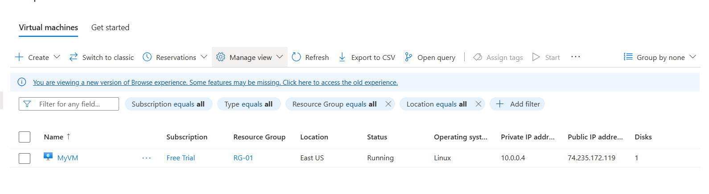
Fig: Virtual machine is created.

Step2: Create a Virtual network gateway (VNG).

Virtual Network Gateway:
In Microsoft Azure, a Virtual Network Gateway (VNG) is similar to AWS's Virtual Private Gateway (VPG). It is a networking component that allows your Azure Virtual Network (VNet) to connect securely to:
- On-premises networks (via VPN)
- Other VNets (via VNet-to-VNet)
- Microsoft services or regions (via ExpressRoute)

Why We Use a Virtual Network Gateway in Azure:
A Virtual Network Gateway is used to establish secure communication channels between:
- Your Azure resources (VMs, web apps, databases)
- Your on-premises environment or data center
- Other VNets or cloud environments

Use Cases:
- Site-to-Site VPN:
  - Connect your on-premises network to Azure securely via IPsec/IKE VPN tunnels.
- Point-to-Site VPN:
  - Allow individual clients (remote users) to securely connect to your Azure VNet using their device.
- VNet-to-VNet VPN:
  - Connect two or more Azure VNets, even across regions.
- ExpressRoute Gateway:
  - Used for connecting on-premises to Azure via a dedicated private connection (ExpressRoute) instead of public internet.
Note: To create VNG we required a separate dedicated subnet in the Vnet (MyVnet).
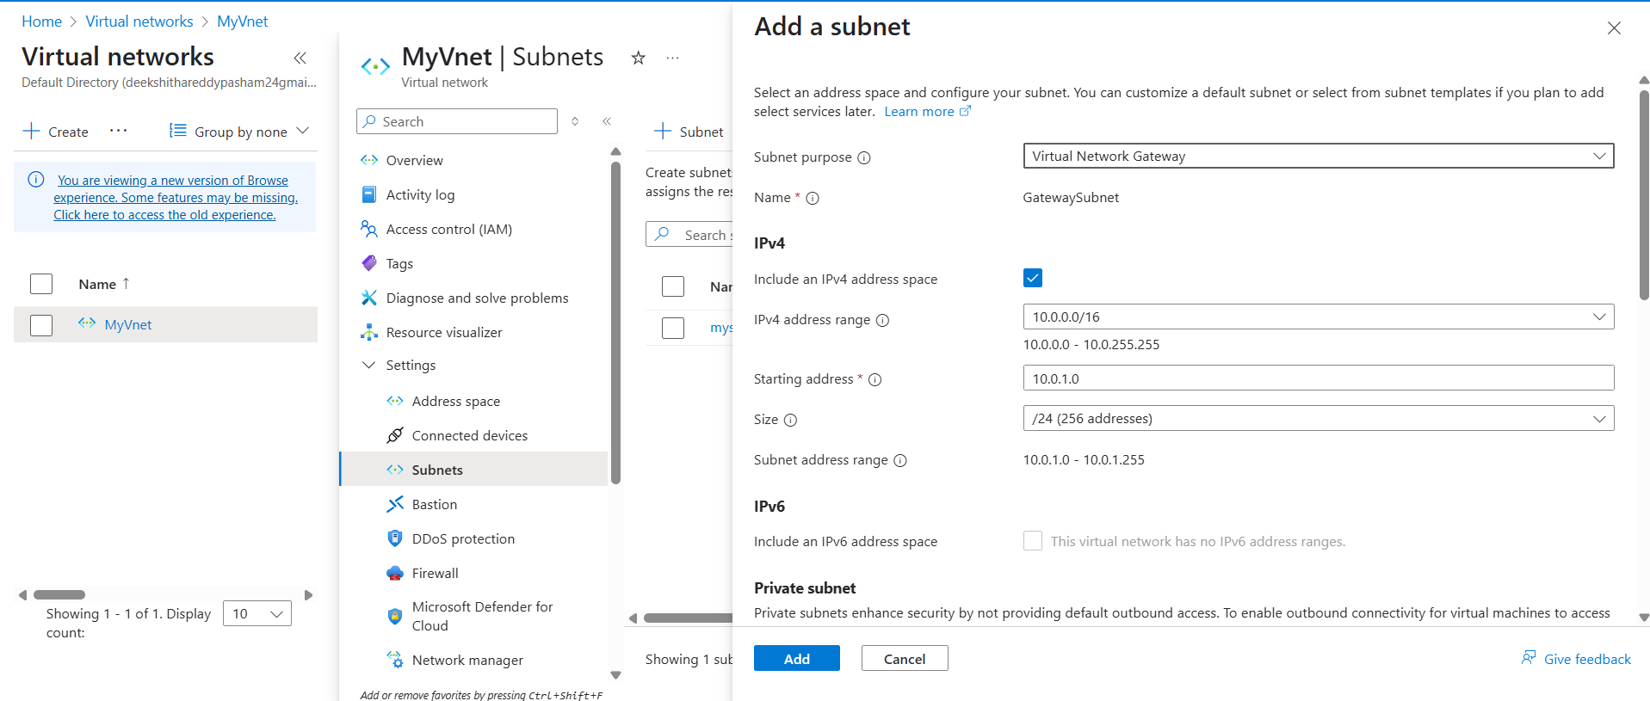
Fig: Creating of dedicated subnet for VNG.

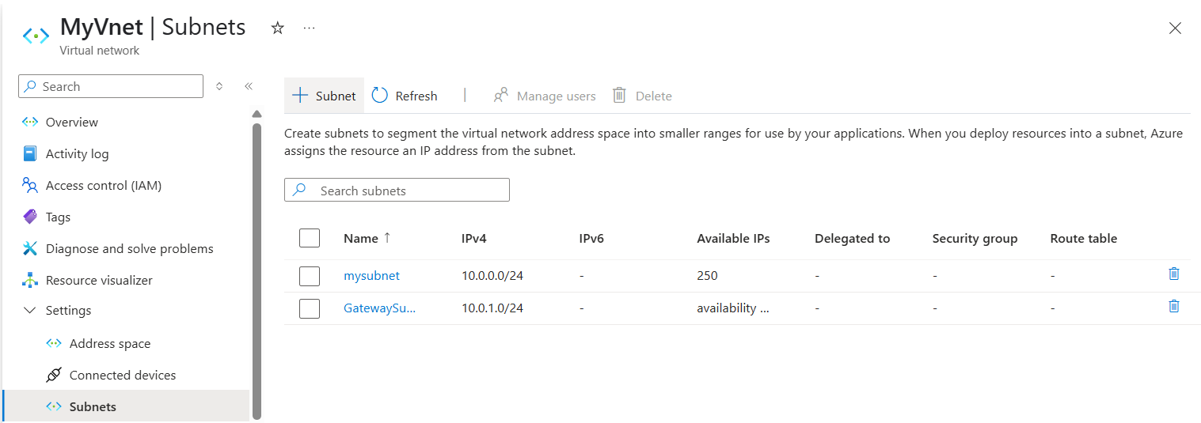
Fig: Subnet (Gatewaysubnet) is created successfully.

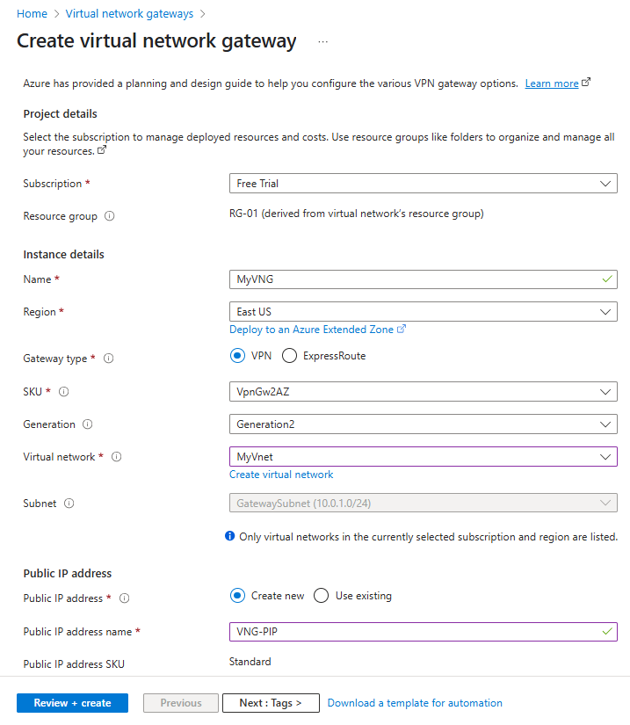

Fig: Configuring of VNG (virtual network gateway).

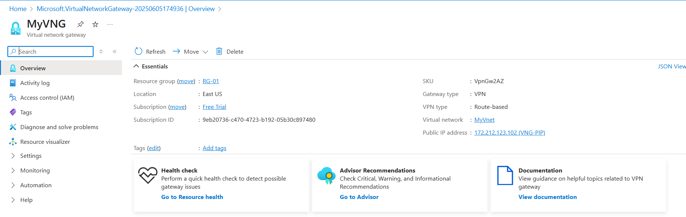
Fig: Virtual network gateway (MyVNG) is created successfully.

Step3: Now create the EC2 instance (Ubuntu) in AWS cloud.

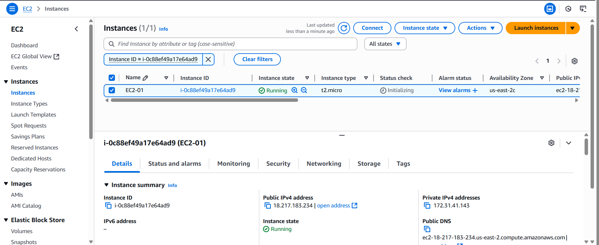
Fig: EC2 instance is created successfully.

Step4: Create the VPG (virtual private gateway) & attach it to the VPC in which EC2 instance created.
Go ToVPC (global search)Virtual private gateway(VPG)create virtual private gateway.

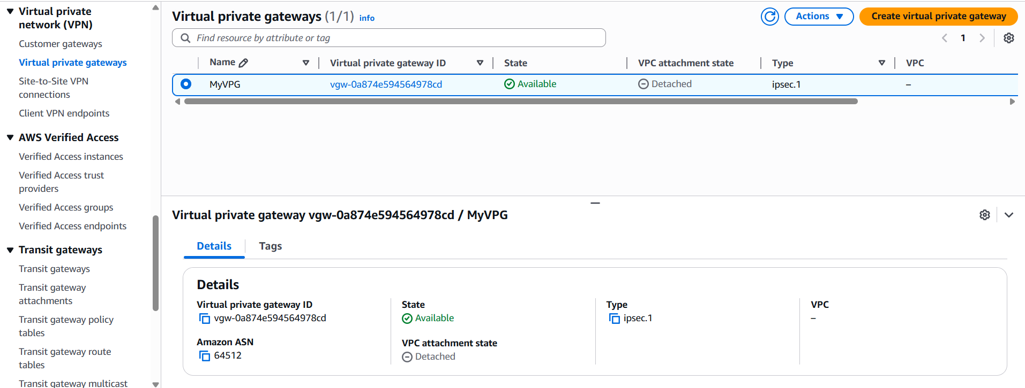
Fig: VPG (MyVPG) is created successfully.

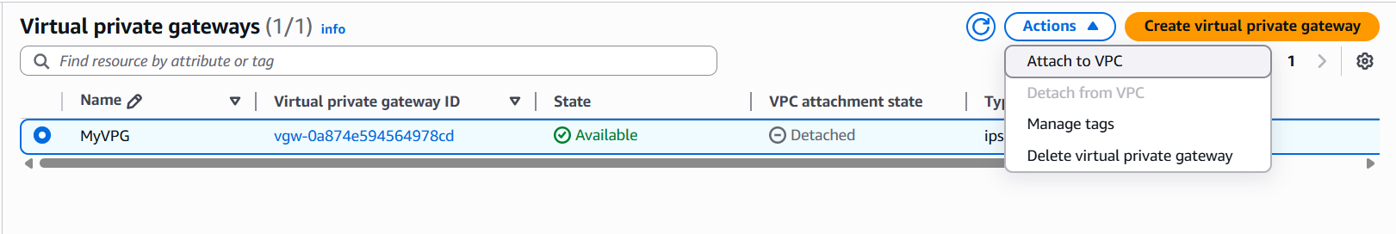
Fig: Attach the VPG (MyVPG) to the VPC (Default-VPC)

Step5: Then configure the Route table to route the traffic using VPG (MyVPG).

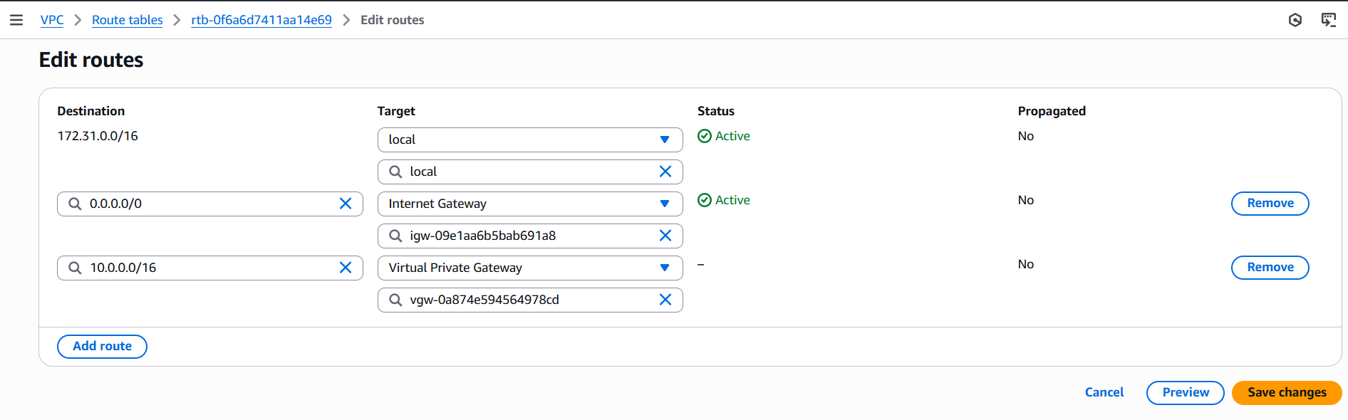
Fig: Configuring of Route table to route the traffic using VPG.

Azure Cloud Virtual network CIDR block: 10.0.0.0/16.

In order to make the secure connection using VPG we have to configure Customer Gateway & Site-to-Site VPN in AWS.

Step6: Create a Customer Gateway in AWS.
Go To VPCCustomer Gatewaycreate customer gateway.

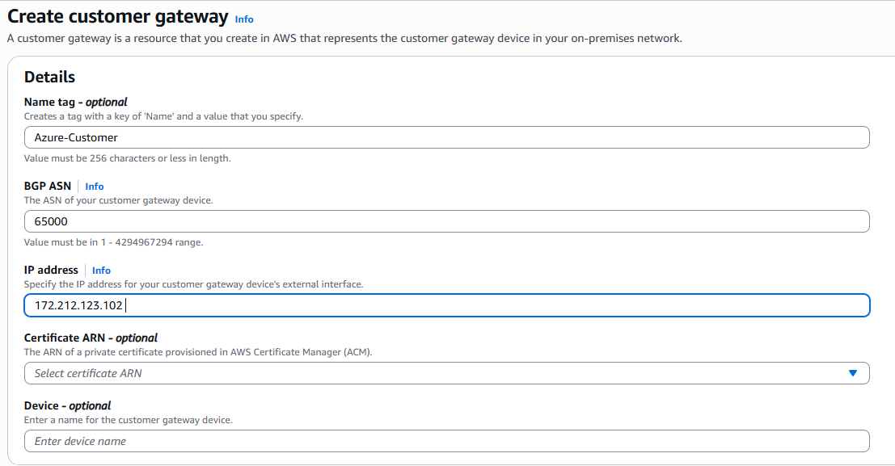
Fig: Configuring of Customer Gateway.
Azure VNG public IP

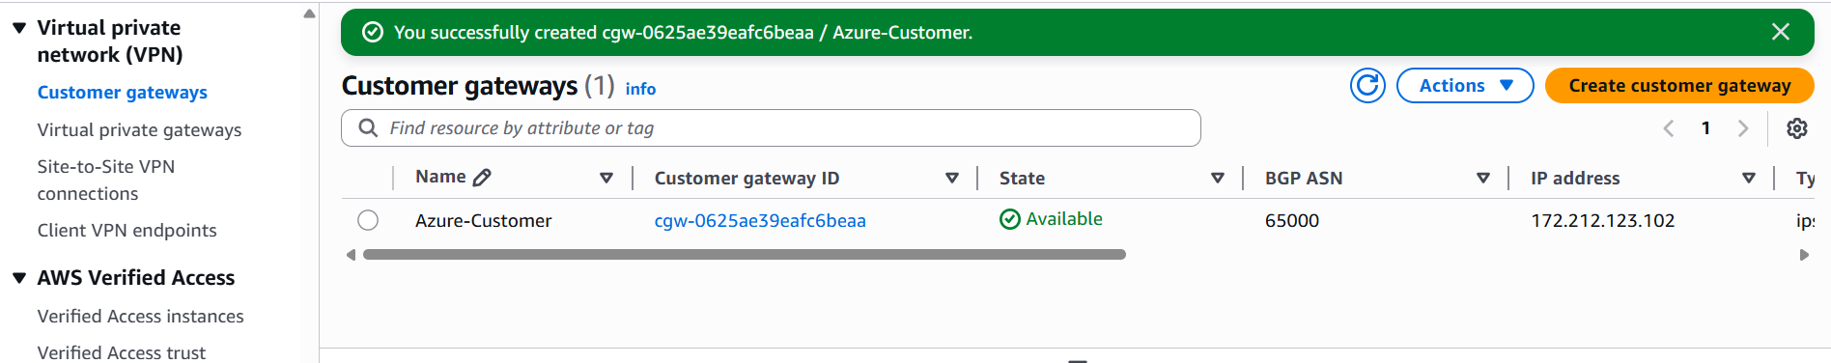
Fig: Customer gateway is created.

Step7: Create the Site-to Site VPN in AWS.
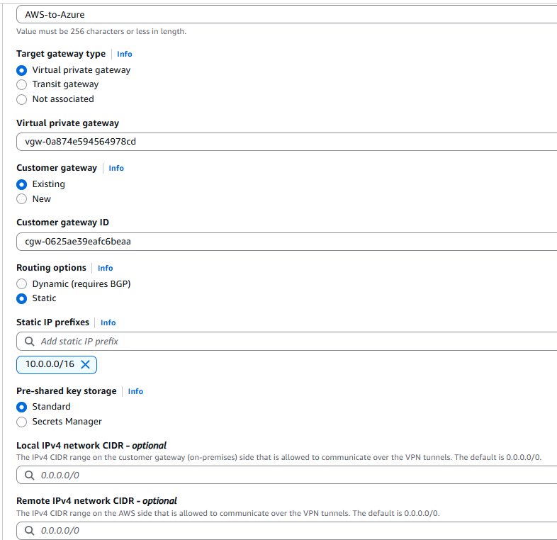
Fig: Configuring of Site-to-Site VPN.
Azure Vnet CIDR block

Now in order now the details of AWS VPG like Public IP, key’s we have to download the configuration file Site-to-Site VPN (Azure-to-AWS).
The file consist of full details of AWS VPG like Public IP, Key’s and so on.

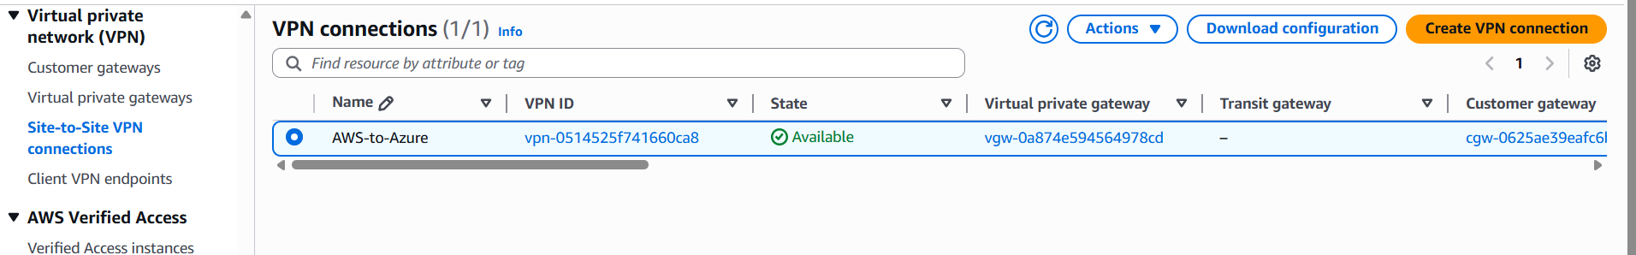

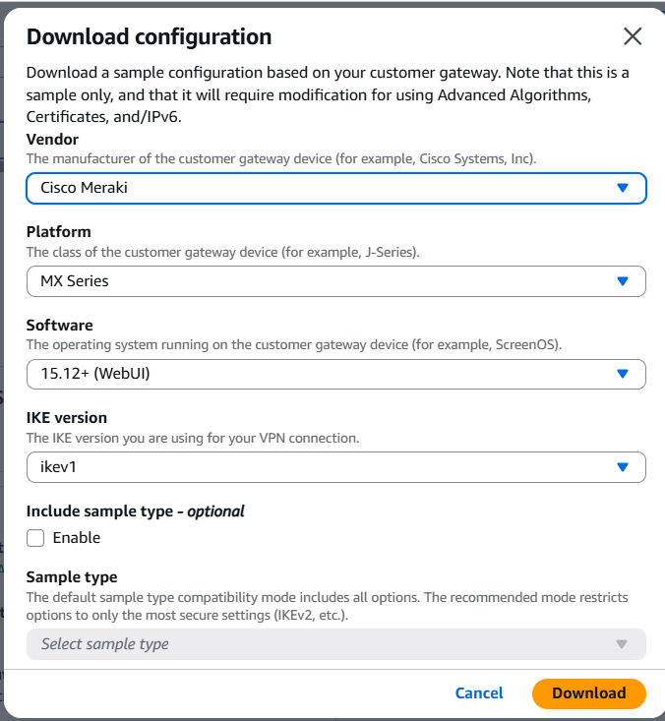
Fig: Download Configuration.

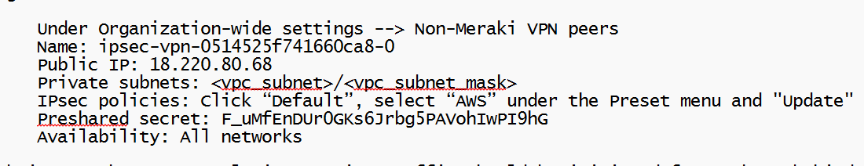
Fig: File content.
Key

Public IP: 18.220.80.68
Key: F_uMfEnDUr0GKs6Jrbg5PAVohIwPI9hG

Step8: Similarly we have to create and configure the local Network Gateway (same as Customer gateway in AWS) in AZURE.

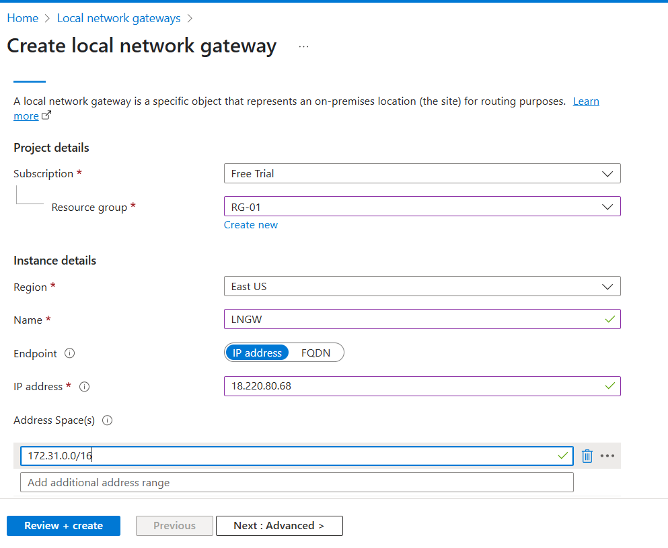
Public IP of Site-to-Site VPN in AWS
CIDR rage of AWS VPC

Fig: Configuring of Local network gateway.

To establish the connection between the Azure VM and AWS EC2, Configure the connection in the azure VNG using the shared key as shown blow figure.

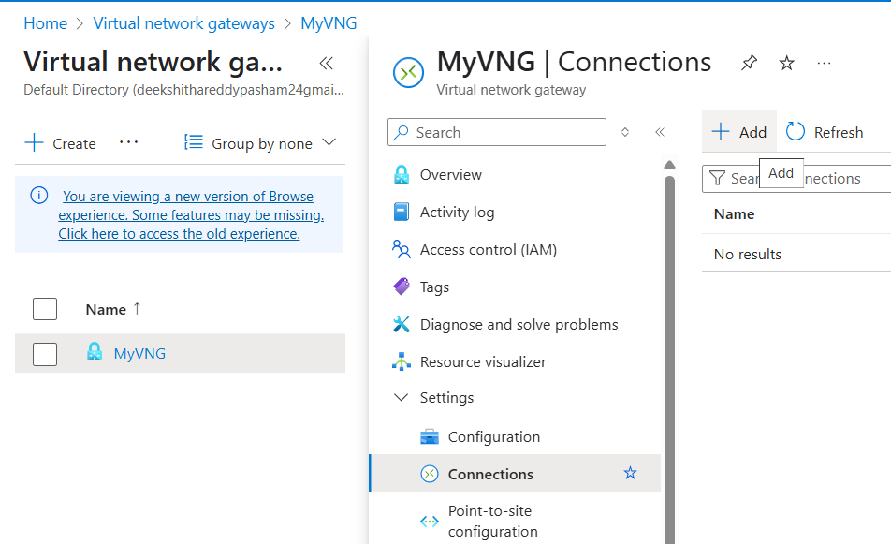

Note: Establishing connection securely using VPN form one cloud to other cloud or cloud to On-premises is called Site-to-Site connection type.
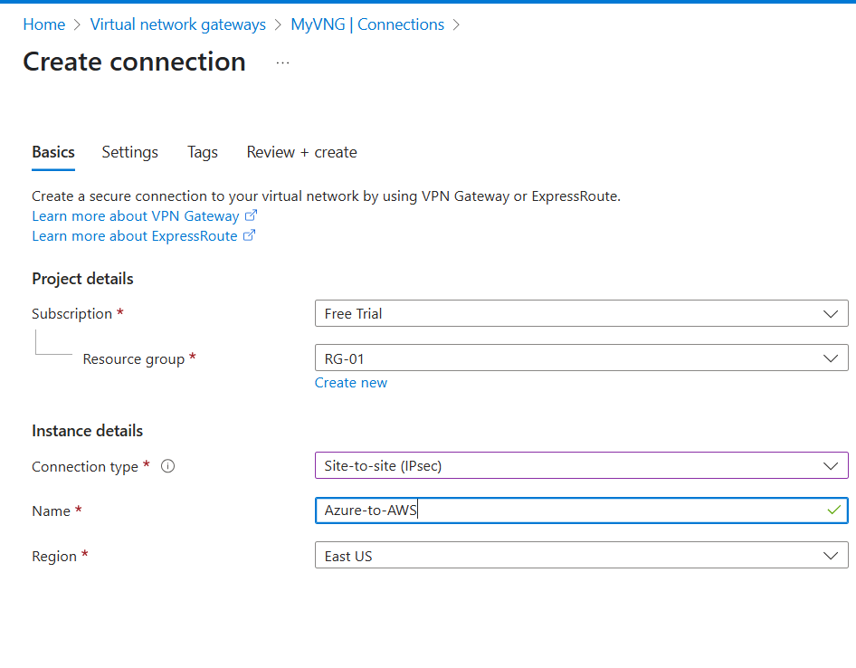
Fig: Connection type Site-to-Site. (Basics).

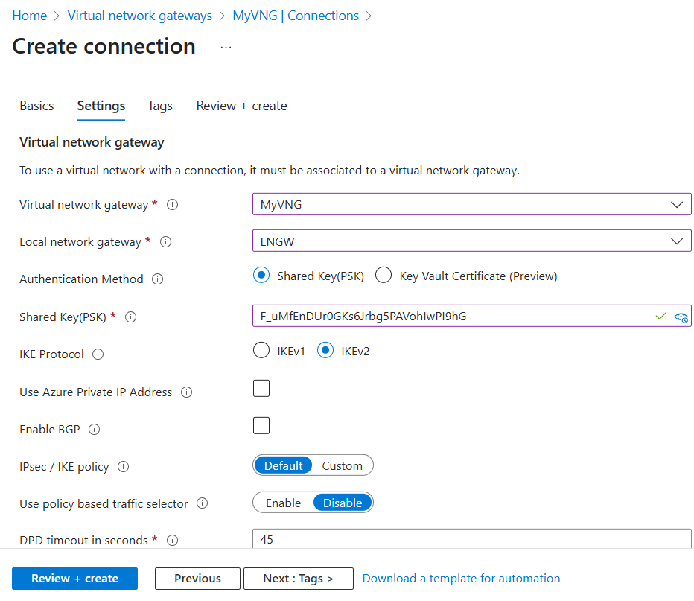

Fig: Connection settings.
Shared key Site-to-Site VPN in AWS.

Step9: Now try to ping the EC2 or VM using private IP and vice versa.

Private IP of VM in Azure: 10.0.0.4
Private IP of EC2 in AWS: 172.31.41.143

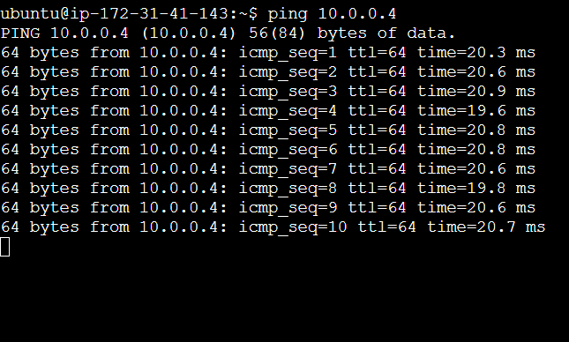
Fig: Pining of VM in EC2 instance.

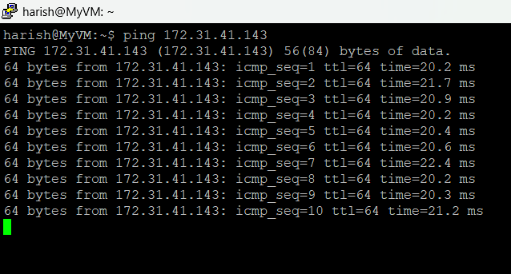

Fig: Pinging of EC2 in VM.

